History 360
A trip to Hudson starts with a little introduction to our town’s history.
There’s no better place to start than the Historic Town Hall and the Green out front.
Town Hall, still the location for civic meetings on the second floor, now also houses the new Destination Hudson Visitors Center and the Fire Museum & Historic Education Society.
The Visitors Center has a wide selection of pamphlets and brochures for first time guests to our town as well as souvenirs.
Town Hall, 27 East Main, is an Italianate building from 1879. Heman Oviatt originally owned this land, and was encouraged to sell it to the First Congregational Church for what became their second building. When the church outgrew that structure, the land passed to the village.
Contractors Thomas Crisp and Charles Stewart built the front part which was then enlarged in 1896 to house the Fire Department. The doors to this addition were closed off in the 1970’s, but are being reopened in the spring of 2016 as we welcome back the fire trucks.
Hudson Rock:
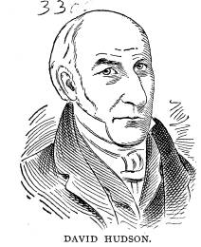
Exiting the front of Town Hall, walk across the street to the Green. Near the Gazebo, you will see a rock that marks the spot of the first public structure in town.
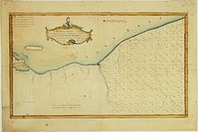
When David Hudson founded our city, Ohio was a wilderness. He was the only one of the original investors to make the trip to the Connecticut Western Reserve in 1799. It was an arduous journey for Hudson, his eleven year old son Ira, and a small group of men from Connecticut to the Western Reserve. Forty eight days later, June 17, 1799, Hudson found the edges of the surveyed township 4, range 10. The first spot they camped was near the western swamp. Soon, however, they made a path into the center of town where they found high ground and a good spring.
David Hudson made the journey back east and returned with a number of pioneer families in 1800. When they finished transferring their supplies to the clearing (no easy task), they gathered on what became the Green for a “service of thanksgiving and praise to Almighty God for bringing them safely through the perils of the voyage,” according to Hudson’s journal.
On this spot, a log structure was built to be used for the school and the Congregational Church.
While the founders intended to have a public square from the beginning (as evidenced by early papers and journals), the Greens weren’t officially deeded to the people of Hudson until 1805 (NE, NW, SE) and 1806 (SW). The Clock Tower Green was added around 1815, possibly the result of the town growing to the north and the “tradition” from troops drilling on the Greens in the War of 1812.

East Main:
Scanning from south to north from the Rock, you will see a stretch of architecture that shows some of the range of houses that still exist in Hudson’s Historic Districts.
***For the best information on structures in the Historic Districts, please refer to the newly updated Hudson Heritage Association website (www.hudsonheritage.org) which has a “house finder” data base for the structures marked with HHA plaques.***
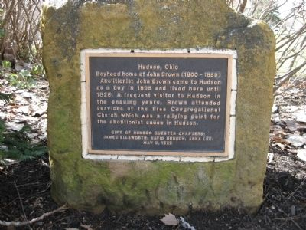
On the southeast edge of the Green, you can see 5 East Main which was originally constructed as the Free Congregational Church. During the early days of the abolitionist movement, Hudson was on the cutting edge of the argument between people who believed in colonization versus those who believed in emancipation. Owen Brown (father of John Brown) was one of the advocates for emancipation.
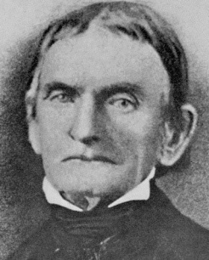
Even though Owen Brown was a prominent citizen, he split with his church and formed a new one, sometimes referred to as the Oberlin Church, on this corner. The structure was originally one story (currently used as the building’s second floor).
Since then it has been a blacksmith shop for Angelo Lavelli (father of Cleveland Browns Hall of Famer Dante Lavelli), and then repurposed for office and retail.

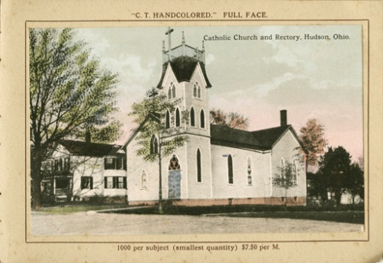
1 East Main (1860) is the next structure as you swing north. This is the “Old Church on the Green.” It was built as a Catholic Church during the railroad boom. The structure’s original location was on Railroad Street (now called Maple Drive).
The church was moved to its current location in 1888 and was raised a bit on a new foundation. Its renovations included adding the front entry and tower, hand digging a cellar, adding a retaining wall, and adding stained glass windows. According to one source, the double doors are from the old Hudson Central School.
When St. Mary’s outgrew the structure and moved to a new building north of town, the Old Church became a multi use building, housing a day care, community activities, and the Spiritual Life Society.
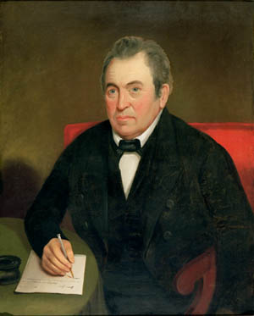
7 East Main (1825) Oviatt House was built for Captain Heman Oviatt (1775-1854), a pioneer and the first mayor of our town when it was incorporated in 1837. Oviatt also operated the first store in the territory about a mile south of town center.
Heman Oviatt helped found Western Reserve College, and endowed it with a professorship that is still continuing at Case Western (now known as the Oviatt Professorship of English).
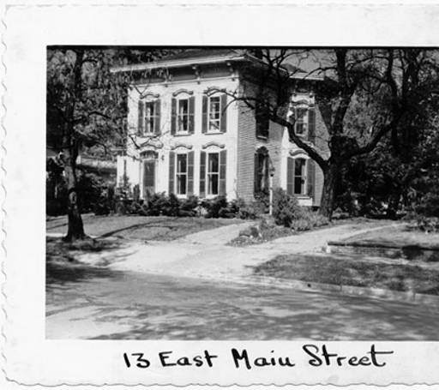
The house has Federal and Greek elements. It was at one time owned by Rev. Mason Grosvenor, pastor of the Congregational Church. In 1888 St. Mary’s purchased the home and converted it into a rectory.
13 East Main (1878) was built by merchant Sebastian Miller. The Italianate style of this house was popular not only in large buildings, like our Town Hall, but is also seen throughout town in houses from this era.

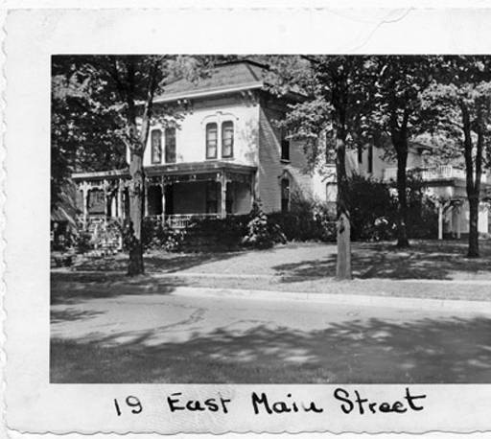
19 East Main (1836/1877) This is the Town-Neibel House. It was built by Leander Starr for Doctor Israel Town (1791-1853), one of Hudson’s earliest physicians. The house was originally a classic Greek Revival with two wings, one on either side. The house was remodeled as a Victorian by Jacob Neibel (1853-1903) in the late 1800’s. The wings were removed, with one becoming the house at 25 Streetsboro Street. (The other wing is presumed to be either part of the house at 30 Church or 26 Streetsboro). At that time, the wrap-around porch was added.
Around 1930, Donald Johnson purchased the home and opened a funeral parlor. The Johnson-Romito Funeral Home still operates there today.
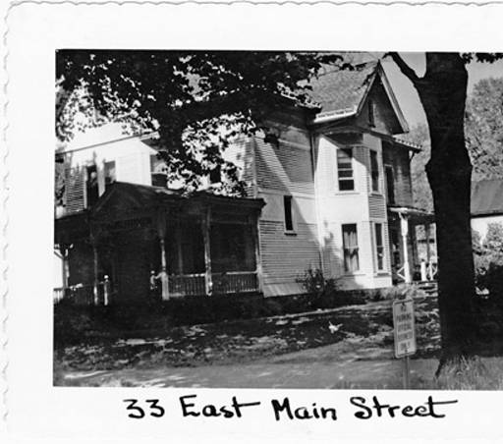
(27 East Main—Town Hall)
33 East Main (1878): shows up first in the tax records under the name of Harvey Whedon, who was probably the builder.
This is one of the earliest of the Queen Anne’s in our town.
In 1891, during the ownership of the Shields family, a new front was done in “Stick style” (vertical, horizontal, and diagonal walls).

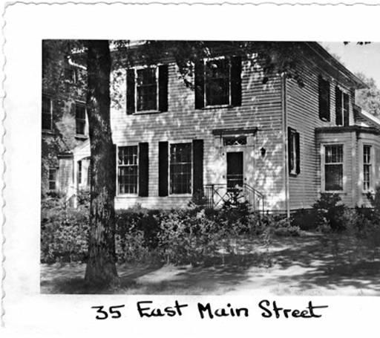
35 East Main (1889) First on this site was a 1826 Federal style house, now at 30 Division.
A.W. Lockhart (1845-1920) moved that home in 1889 and built this Victorian style home on the old foundation. Lockhart was the owner of the Hudson Bakery, as well as a saloon on Main Street where the Great Fire of 1892 had its start.
Renovations in the 1930’s changed the gable to a hipped roof, rearranged the front windows and removed the side porch.
41 East Main (1841): The Ellsworth Store building at the corner of East Main and Division was built by Leander Starr for Edgar Birge Ellsworth, father of industrialist James Ellsworth.
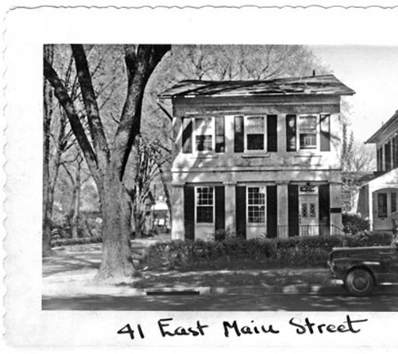
Edgar Birge Ellsworth served as mayor of Hudson from 1853 to 1855 and is especially impressive because he became an influential leader and businessman in spite of being confined to a wheelchair.
This building has been used continuously for business since its construction, housing such things as a grocery, a meat market, a bakery, and a dentist’s office. The upper floors have housed several newspaper offices and a photography studio.

22 Aurora (1834) Babcock Baldwin House: This typical Greek Revival house currently is the location of Hudson Heritage Association and Hudson Community Foundation.
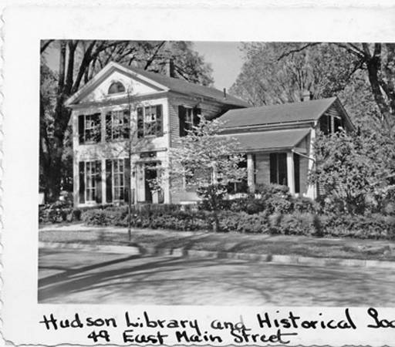
It is named for Carolyn Babcock Baldwin as well her parents, Frederick Salome Bronson Baldwin. Carolyn Babcock Baldwin was an early advocated of a Hudson public library. Granted, David Hudson had a lending library from 1802, and Western Reserve library served the town. However, by the early 1900’s, no true public library was left.
Baldwin-Babcock was instrumental in organizing citizens to form a free library to be housed at the Club House (currently called Seymour Hall). Her letter to James Ellsworth, requesting support, is on file at the HLHS archives.
When Carolyn Babcock Baldwin died, she left a bequest to the library, with which they bought the Baldwin family home for the HLHS. The house remained the front of the library until it moved in 2005. The house was then separated from the later addition (currently the Morgan Foundation) and restored to its earlier condition.
Aurora Street, going to the northeast, is one of our oldest roads. It was originally called Paine’s Road and provided a route to early settlements in Geauga County.
It was also dubbed the most beautiful street by James Ellsworth. In one of the industrialist’s efforts to improve his hometown, trees were planted on Aurora. His estate, Evamere, was located about a mile up the street.
Brewster Block is the part of Aurora Street that touches the northern edge of the Green.
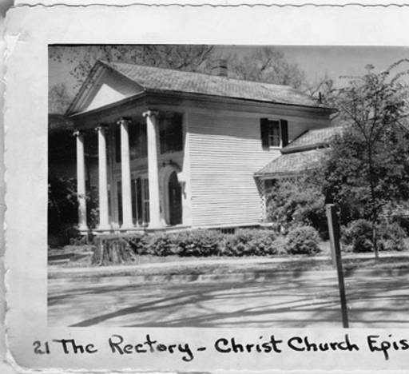
21 Aurora (1834): The Isham Beebe House was built for the Isham family by Leander Starr. Warren Isham was the publisher of the “Hudson Observer and Telegraph,” a newspaper of wide circulation in the 1830’s. His son, Warren, who was raised in the house, went on to become an editor at the Chicago Times.
During the 1850’s successful local merchant AA Brewster bought the house and sold it to his daughter Ellen. Ellen was the wife of Duncan Beebe, who ran AA’s business holdings after his death.
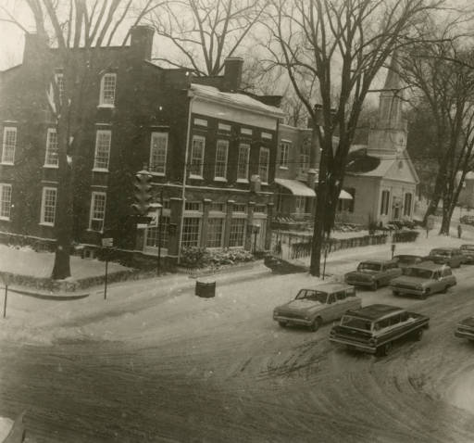
Christ Church Episcopal acquired the house from the estate of Jesse Beebe Hodge, Ellen and Duncan’s daughter, in 1945.
9 Aurora (1853): Brewster Mansion was built by Frederick Bunnell as the home of AA Brewster after a fire destroyed the earlier family home on the same spot. (Stories have wife, Sarah White Brewster, being carried from the house fire on a mattress, having recently had a baby.)
Brewster’s Mansion currently houses a number of shops. In the past, it has been used as a nursing home (The Elms, now on Streetsboro) and a hotel (Park Hotel)..
Note the Gothic styling which makes this a standout along the Green.
5 Aurora (1839): Brewster Store has been in use as a business of some sort continuously since 1839.
The Federal style brick structure was built by Leander Starr for AA Brewster. James Ellsworth restored it in 1908 for his bank, taking off a wooden wing on the west side that had been added by Duncan Beebe.
It was an attempt to modernize the building in 1962 that caused Hudsonites to become alarmed about the destruction of historic buildings around town. This group formed the core of what became the Hudson Heritage Association.
**For more information on structures throughout the Historic District to the east as well as around WRA, check out the HHA website at www.hudsonheritage.org. ***

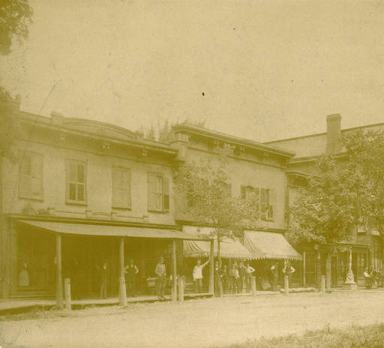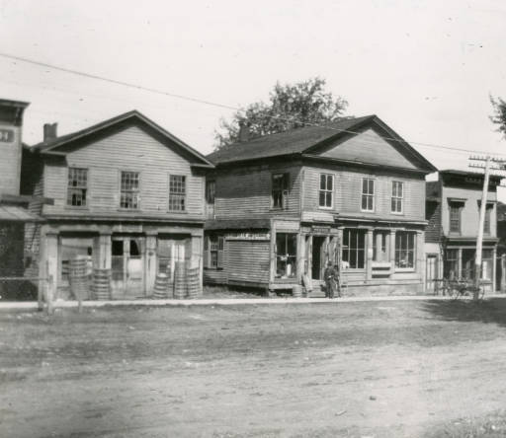
North Main
Looking along the western edge of the Green, visitors can see our Historic Main Street. Filled with shops and restaurants, it is an authentic historic face to the First and Main structures behind.
If you look carefully, you’ll see a difference in the buildings south of Clinton and the ones to the north.
That’s because in 1892, Hudson businesses suffered a catastrophic fire.
Starting at Lockhart’s Tavern (approximately the site of the current Kepner’s), the fire burned through the entire section until it reached the brick walls of Adelphian Hall. Hudson fire fighters put out a call for assistance and did their best with water pumped from cisterns (standard for that day). However, before anyone could help, the entire block went up in flames. Thankfully, a rain storm and the brick of the Hall helped stop the fire.
Clock Tower
Looking at the intersection of Aurora and North Main, visitors see Hudson’s most visible landmark, the clock tower.
The clock tower is just over a hundred years old. In fact, the town held it a “birthday celebration” in 2013 to mark the event.
This structure was not always so popular with the citizenry.
First, there were some townspeople who didn’t appreciate James Ellworth’s generosity in building it. The industrialist had ruffled some political feathers with his modernization projects. (We now, of course, are grateful to be the beneficiaries of such things as underground wires and beautified streets.)
Second, when repairs for the tower came up in the 1930’s, the town budget was tight. A serious conversation about moving the clock works to Town Hall and razing the tower was underway.
Fortunately, even then there were “preservationists” in Hudson. A committee was formed to raise money for repairs and the clock tower was saved.
Now it stands as a symbol of both progress and preservation—the core beliefs of Hudson.

Pictures are part of the archive collection, available digitally at www.summitmemory.org. Visit that site for many more photos of our town.
In person, visit the Hudson Library and Historical Society archives (on Library Street), located on the second floor of the “new” HLHS building.

